Docker — Three-Tier Architecture:
- Deploy a three-tier application using Docker Compose: Frontend (Nginx/React) → Backend API → Database (choose MySQL or PostgreSQL).
- Configure Docker networks, persistent volumes, health checks, environment variables, restart policies, and service dependencies. Expose only the frontend externally. Demonstrate how you would troubleshoot frontend → backend and backend → database connectivity issues.

AWS EKS + ALB Controller — Three-Tier Architecture:
- Migrate the same application to Amazon EKS, continuing with your chosen MySQL or PostgreSQL database. Deploy the frontend, backend, and database using Kubernetes resources. Use ClusterIP for internal communication and expose the frontend using Ingress + AWS Load Balancer Controller (ALB). Configure Secrets/ConfigMaps, persistent storage, probes, IAM/IRSA or Pod Identity, and scaling. Demonstrate troubleshooting of Internet → ALB → Ingress → Service → Pod → Backend → Database, including ALB 503 and unhealthy-target scenarios.
=================================================================
Docker — Three-Tier Architecture:
- Deploy a three-tier application using Docker Compose: Frontend (Nginx/React) → Backend API → Database (choose MySQL or PostgreSQL).
- Configure Docker networks, persistent volumes, health checks, environment variables, restart policies, and service dependencies. Expose only the frontend externally. Demonstrate how you would troubleshoot frontend → backend and backend → database connectivity issues.

Implementation: -
Here I am using as Docker Three-Tier web Application (Frontend → Backend API → PostgreSQL).
I implementing the same three-tier architecture without Docker Compose by creating and managing each container manually using docker network, docker volume, and docker run commands.
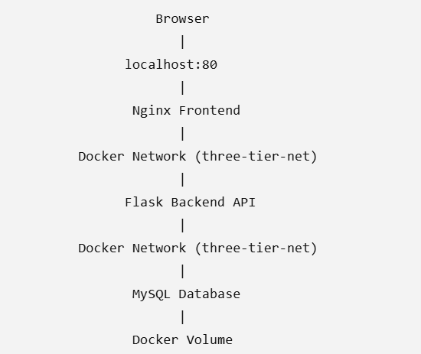
#Here only Nginx will be exposed
A-Create Docker Network
#creating docker network “three-tier-net” as above
$docker create network three-tier-net
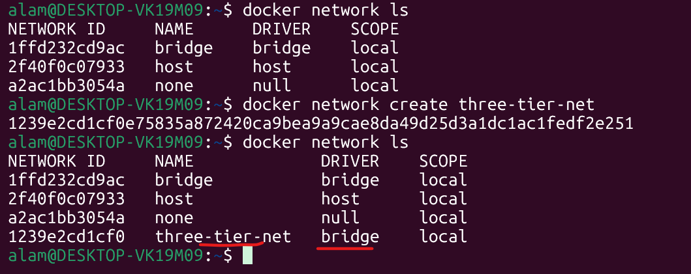
B-Create Persistent volume
$docker volume create mysql-data
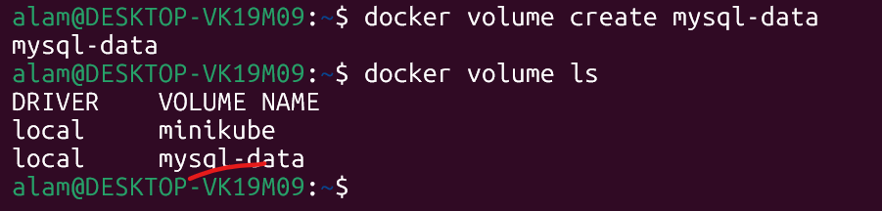
C- Run MySQL Container
$ docker run -d --name mysql-db --network three-tier-net -v mysql-data:/var/lib/mysql -e MYSQL_ROOT_PASSWORD=root123 -e MYSQL_DATABASE=employee_db -e MYSQL_USER=admin -e MYSQL_PASSWORD=admin123 --restart unless-stopped mysql:8.0
MYSQL_USER=admin -e
PASSWORD=admin123
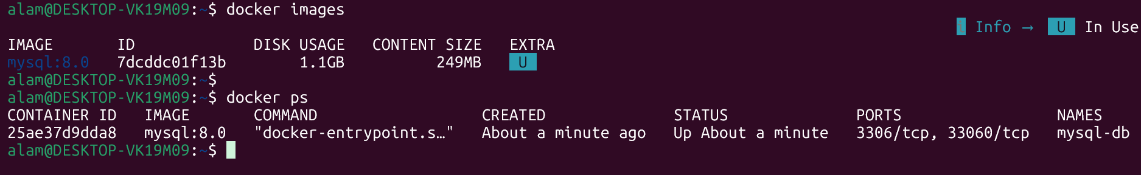
D - Backend Application

#/home/alam/three-tier-app/backend/app.py
from flask import Flask
import mysql.connector
import os

app = Flask(__name__)

db = mysql.connector.connect(
host=os.getenv("DB_HOST"),
user=os.getenv("DB_USER"),
password=os.getenv("DB_PASSWORD"),
database=os.getenv("DB_NAME")
)

@app.route("/")
def home():
return "Backend Connected Successfully!"

@app.route("/db")
def dbcheck():
cursor = db.cursor()
cursor.execute("SELECT DATABASE();")
return cursor.fetchone()[0]

app.run(host="0.0.0.0", port=5000)

# /home/alam/three-tier-app/backend/requirements.txt
# requirements.txt
flask mysql-connector-python

Backend Dockerfile
# /home/alam/three-tier-app/backend/ Dockerfile
FROM python:3.11-slim

WORKDIR /app

COPY requirements.txt .

RUN pip install --no-cache-dir -r requirements.txt

COPY . .

EXPOSE 5000

CMD ["python","app.py"]

E-Build Backend Image
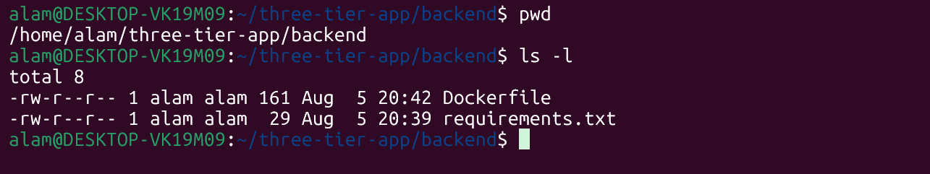# docker build -t flask-backend:v1 .

F- Run Backend Container
docker run -d \ --name backend-api \ --network three-tier-net \ -e DB_HOST=mysql-db \ -e DB_USER=admin \ -e DB_PASSWORD=admin123 \ -e DB_NAME=employee_db \ --restart unless-stopped \ flask-backend:v1
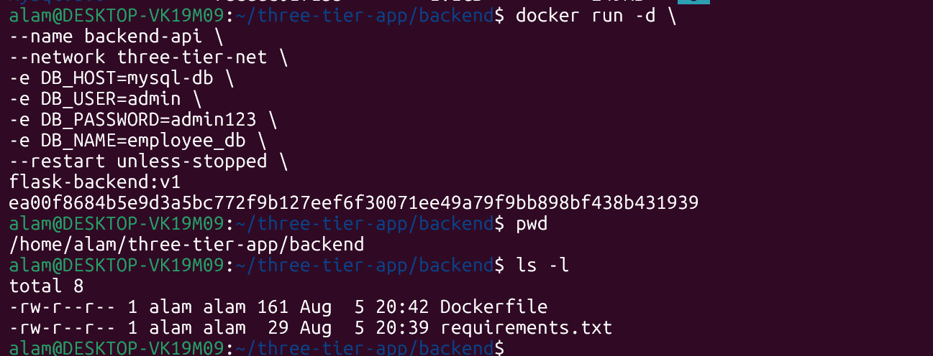

G- Frontend --inside fronted dir
Index.html
<!DOCTYPE html>

<html>
<head>
<title>Three Tier App</title>
</head>

<body>

<h1>Docker Three Tier Application</h1>

<button onclick="load()">Connect Backend</button>

<p id="result"></p>

<script src="script.js"></script>

</body>
</html>

script.js -- inside fronted dir
async function load(){

const response = await fetch("/api");

const data = await response.text();

document.getElementById("result").innerHTML=data;

}

nginx.conf --- inside fromtend dir
events {}

http {

server {

listen 80;

location / {

root /usr/share/nginx/html;

index index.html;

}

location /api {

proxy_pass http://backend-api:5000;

}
}
}

Frontend Dockerfile
Dockerfile -- inside the frontend file

FROM nginx:latest
COPY index.html /usr/share/nginx/html/
COPY script.js /usr/share/nginx/html/
COPY nginx.conf /etc/nginx/nginx.conf

#cd frontend
# docker build -t nginx-frontend:v1 . --- frontend image building in progress
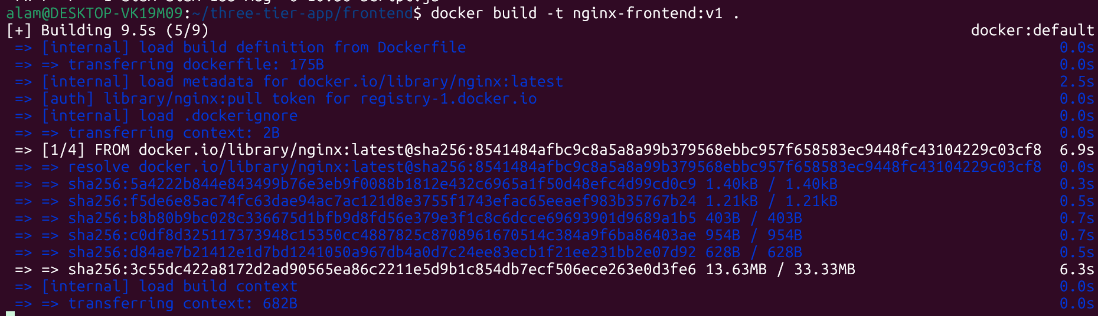
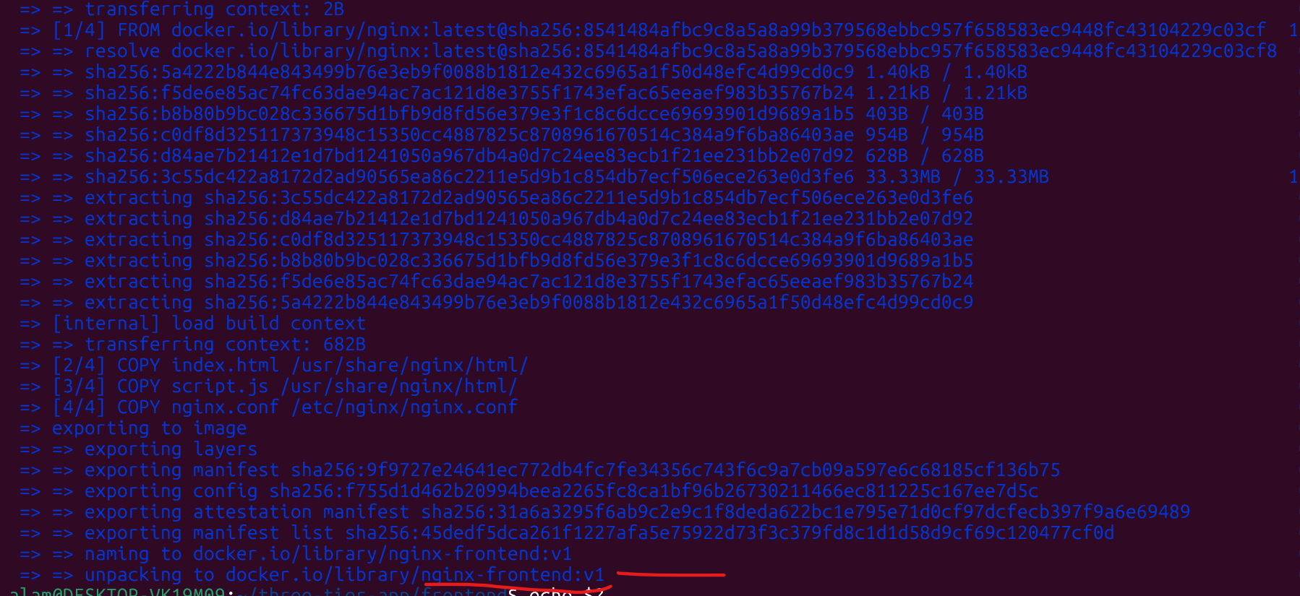
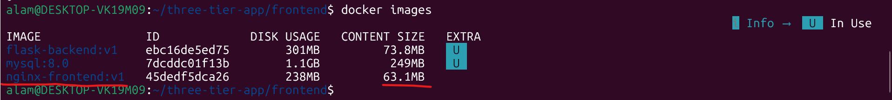

H - Step 9 Run Frontend Container - from above created nginx-frontend:v1 image
# docker run -d --name frontend --network three-tier-net -p 80:80 --restart unless-stopped nginx-frontend:v1
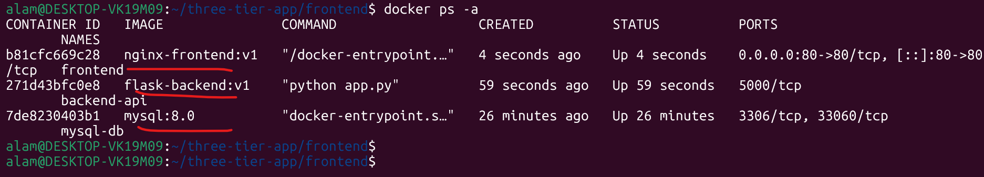
Note: Here only port 80 is open for public. Backend DB remain private
Architecture
Frontend http://backend-api:5000 Backend mysql-db:3306 Database
I – Network check and connectivity
$ docker network inspect three-tier-net ----
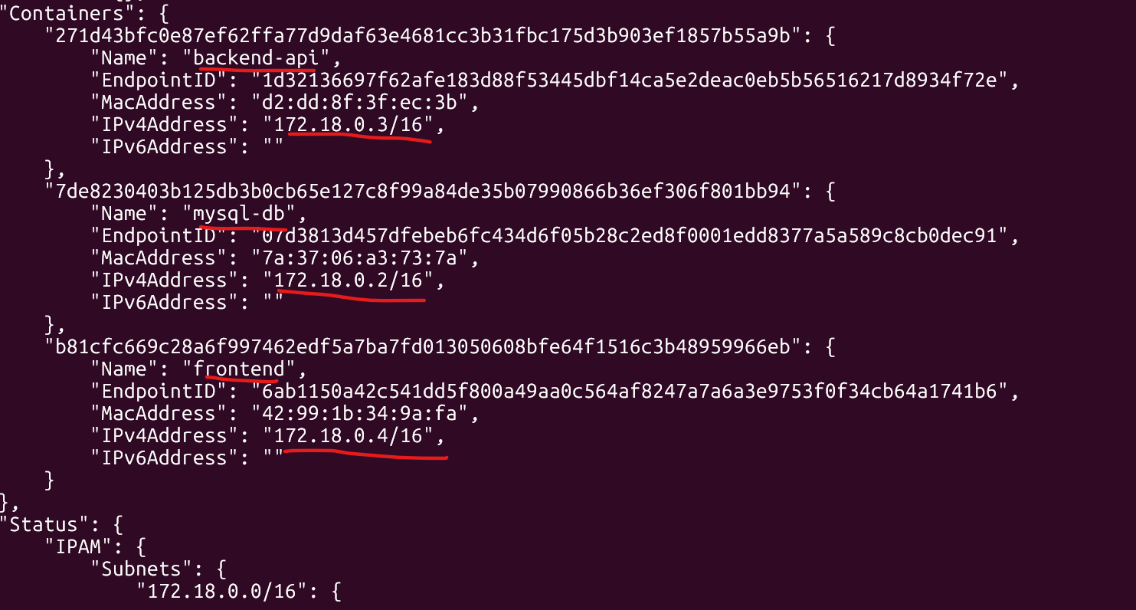
J – Storage check and connectivity
# docker volume inspect mysql-data
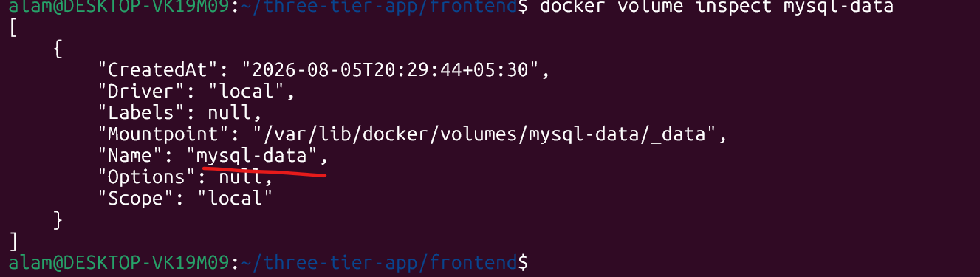
K – Check Backend DB and connectivity
$docker exec -it backend-api bash
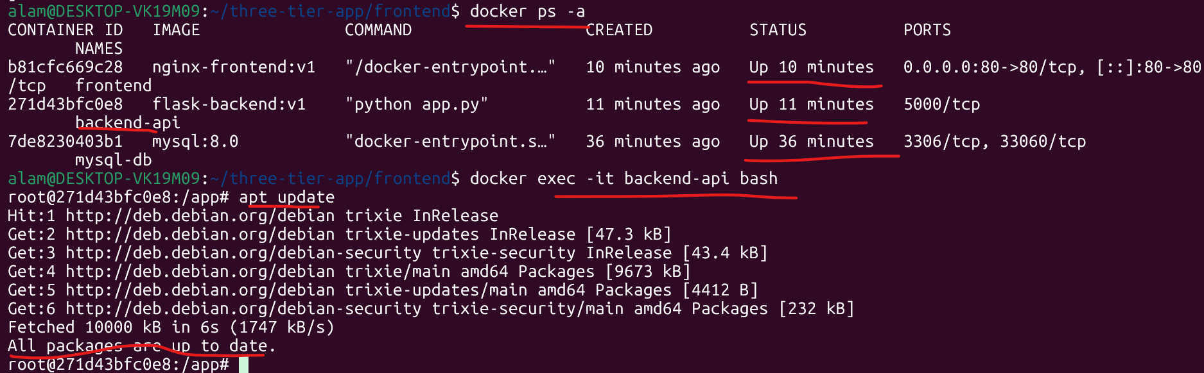

# Ping database
$ apt install iputils-ping -y ---- to install ping, first update the os, apt update
$ping mysql-db
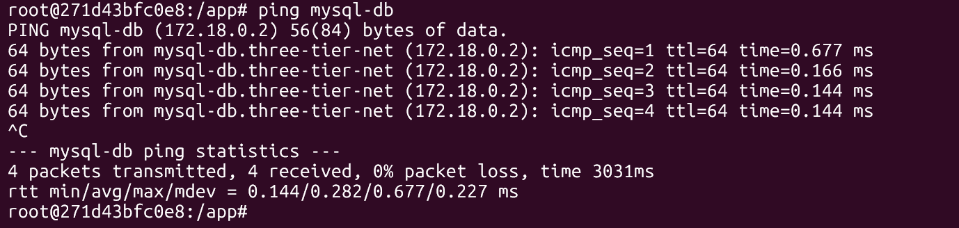
$ python
$ import mysql.connector mysql.connector.connect( host="mysql-db", user="admin", password="admin123", database="employee_db") ---- no error means it fine
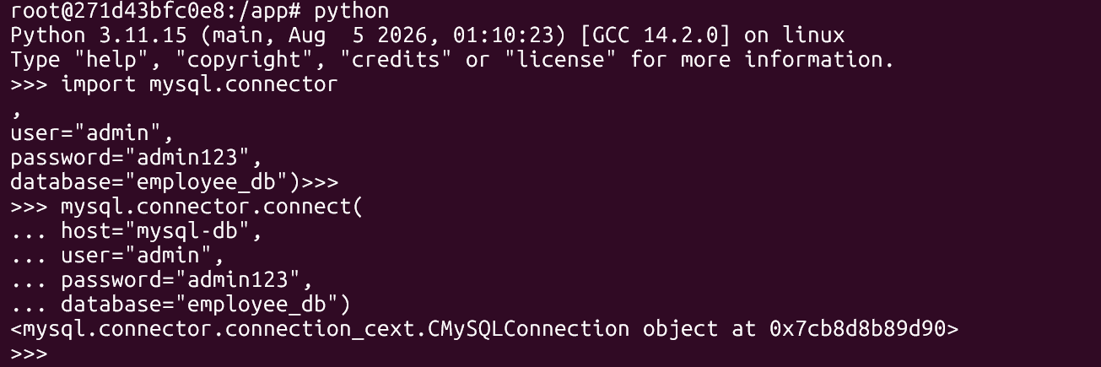

Backend IP :- 172.18.0.3
L- Verify Frontend → Backend --- donfirm db, and backend connectivity is ok.
$docker exec -it frontend bash -- login to frontend
$ ping mysql-db ---- db connectivity check from frontend
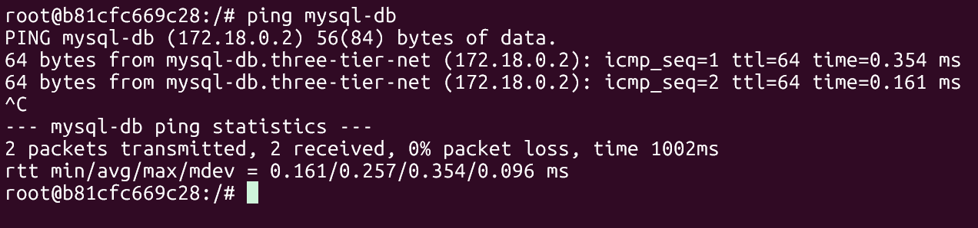
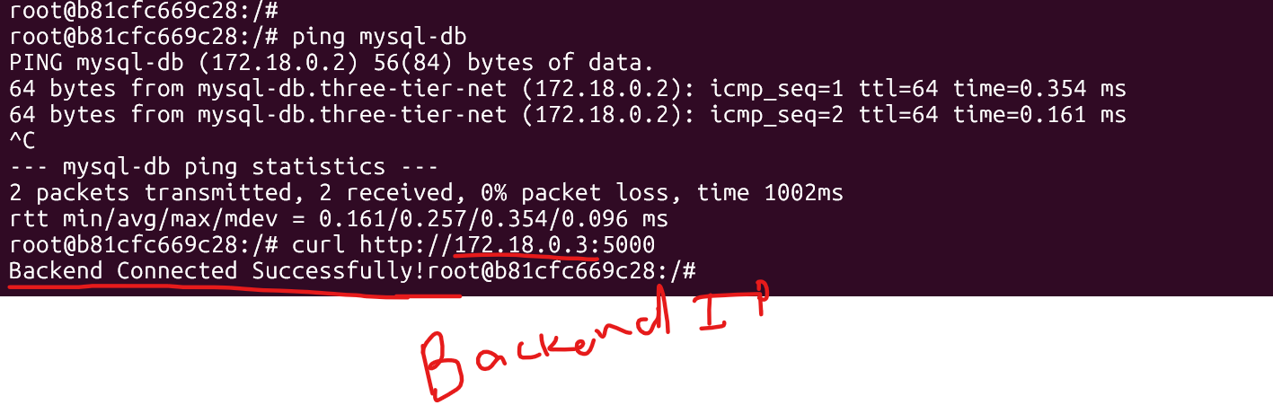
donfirm db, and backend connectivity is ok.

#Docker Over all all the service health check with
#Docker ps -- as below.
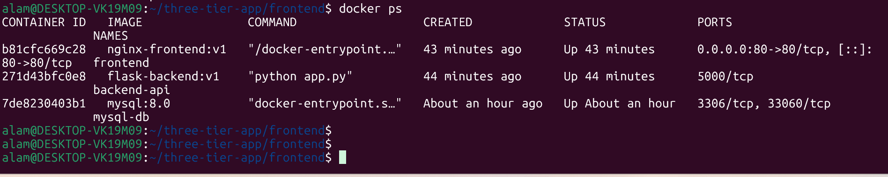
================================================================
Overall projects overviews.
Environment Variables -- used during mysql_db --- image creation
Pass all configuration through -e options, for example:
-e DB_HOST=mysql-db
-e DB_USER=admin
-e DB_PASSWORD=admin123
-e DB_NAME=employee_db

Service Dependencies
Without Docker Compose, Docker does not wait for dependent services. Start containers in this order:
- MySQL
- Wait until MySQL is healthy (docker ps or docker inspect). To debug if needed
- Backend
- Verify backend is healthy.
- Frontend

Troubleshooting

Frontend → Backend
docker exec -it frontend sh
curl http://backend-api:5000
If it fails:
- Verify both containers are on three-tier-net: --- on same network
docker network inspect three-tier-net --- network debug
- Check backend logs:
docker logs backend-api -- backedn-api debug
- Confirm Nginx proxy configuration:
docker exec -it frontend nginx -t -- debug and check the frnt

Backend → Database
docker exec -it backend-api bash
Test connectivity:
ping mysql-db
If it fails:
- Check MySQL logs:
docker logs mysql-db
- Verify the database container is healthy:
docker inspect --format='{{.State.Health.Status}}' mysql-db

Make sure credentials and database name match the environment variables.

